1. Screenshots

a.Index page

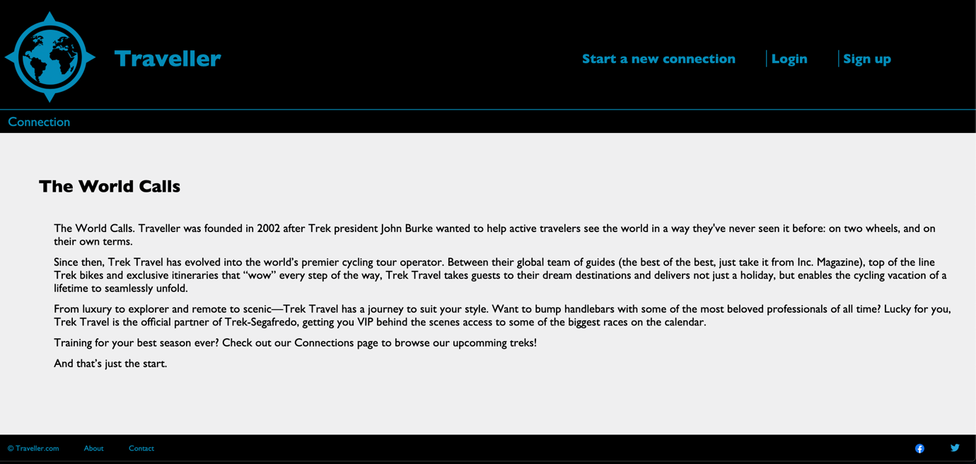

b. Connections page

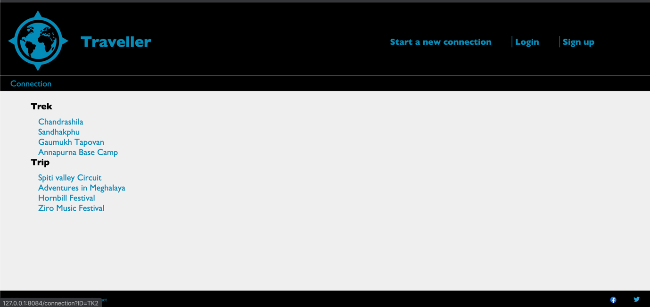

c. Connection page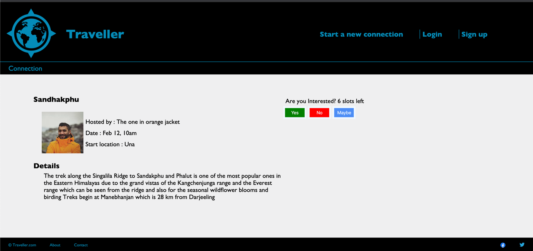

d. saved connections page

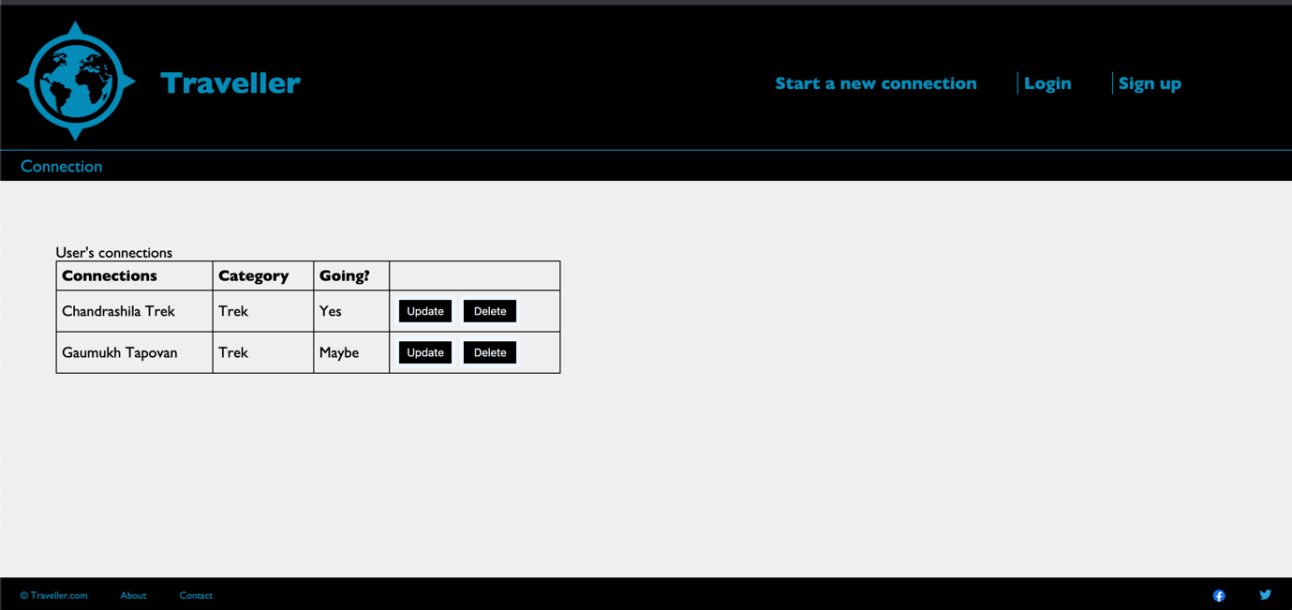

e. new connection page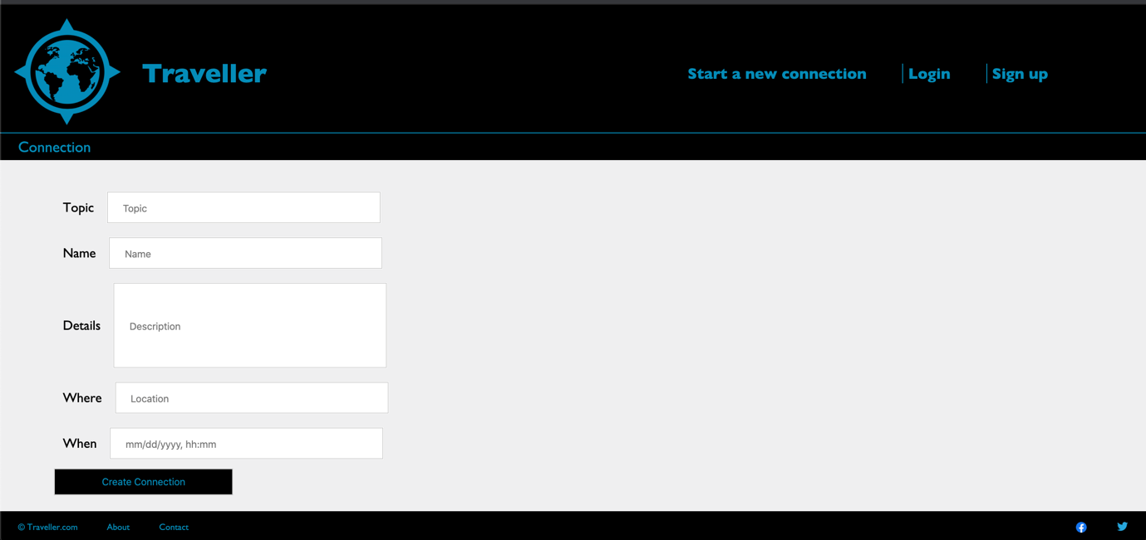

f.about page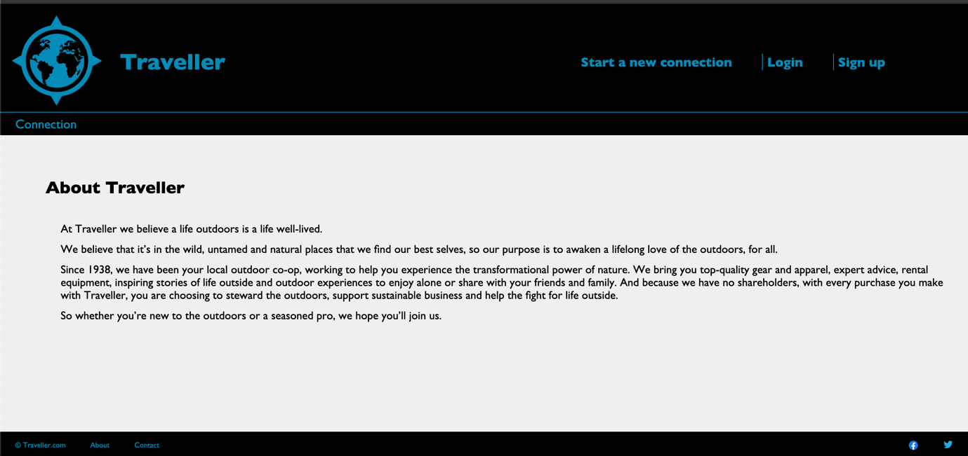

g.contact page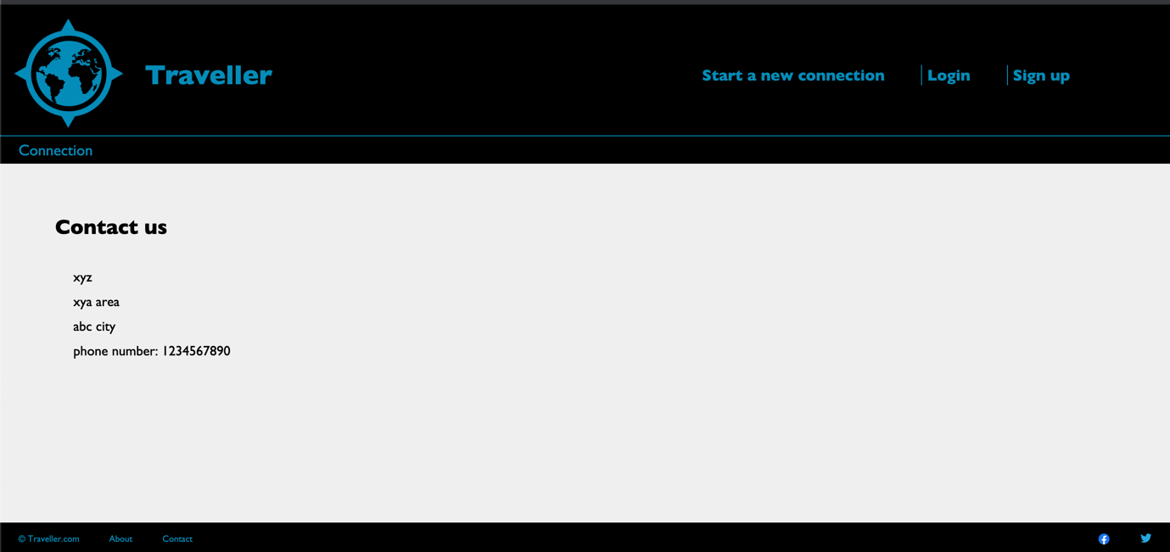

1. Additional features:None
2. Status, Stopping Point or Issues

The assignment status is complete. No issues.

1. Experience

* Challenges
* Setting the default route
* Setting up getter and setter to word with model.
* Solutions
* Referred to previous tutorials and examples
* Doubt was cleared on Piazza
* Easy part
* Setting up new connection page.